

New NHS Pharmacy First Service being offered from community pharmacies from 31st January 2024

This involves pharmacists providing advice and prescription treatment, including antibiotics where clinically appropriate, for seven common conditions:

* Sinusitis Sore throat
* Acute otitis media (earache)
* Infected insect bite
* Impetigo
* Shingles
* Uncomplicated urinary tract infections

**Contact Number**

**01204 309206**

**Email Address**

[**Gp.p82023@nhs.net**](mailto:Gp.p82023@nhs.net)

**Mandalay’s**

**February**

**Newsletter**

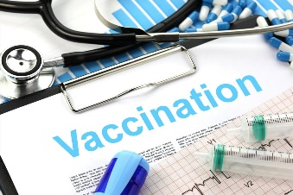

Think Measles – it’s not just a kids’ problem

It’s never too late to have your MMR vaccination

**Prescriptions**

Where possible the prefered method to order would be via email to [gp.p82023@nhs.net](mailto:gp.p82023@nhs.net). Alternatively requests can be made in writing and placed in the box in reception.

**DID NOT ATTEND!**

**171** patients didn’t attend their appointment in December.

If you are unable to attend your appointment please let the surgery know, we can then allow another patient to be seen in your place.

**Turton PCN**

Did you know that you can book appointments with multiple different clinicians at other surgeries. Please ask reception for more information.

Please remember to follow us on Facebook

Mandalay Surgery Notice Board

