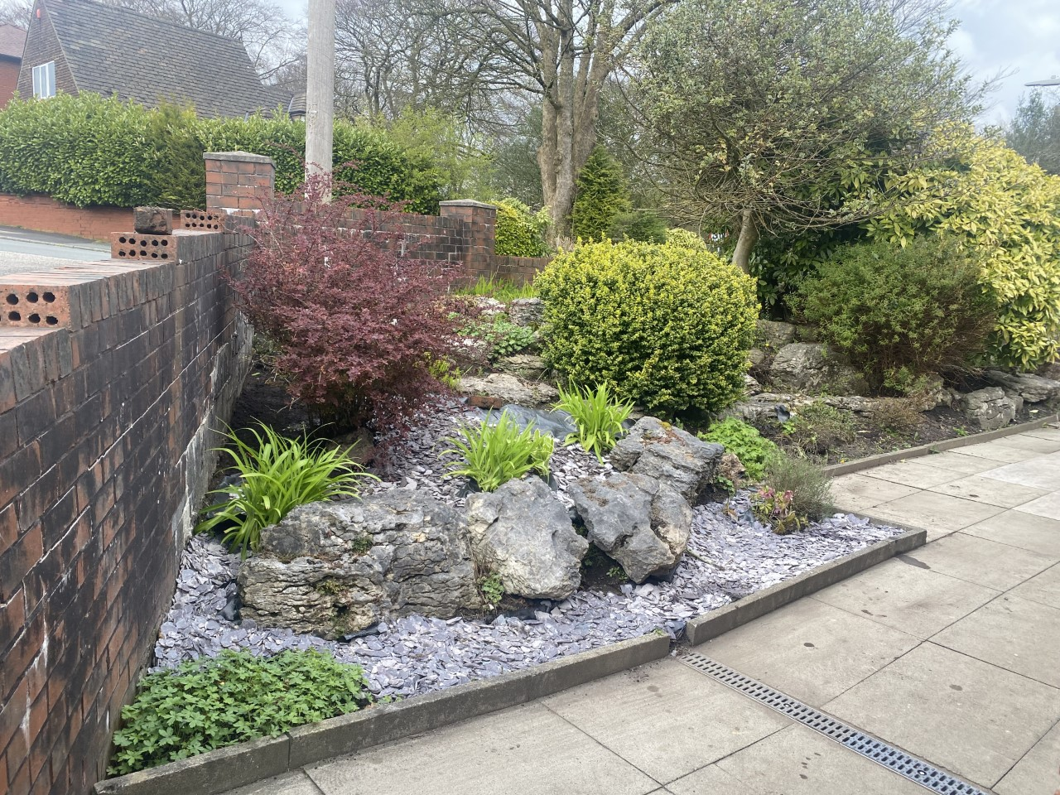

01204 309206 [Gp.p82023@nhs.net](mailto:Gp.p82023@nhs.net)

Please remember to follow us on Facebook Mandalay surgery notice board

**Mandalay’s**

**September Newsletter**

**Shingles**

Are you turning 65 or 70? If so, you will then be eligible for the shingles vaccine. Please contact the surgery to book a slot at one of our shingles clinics.

**Prescriptions**

We have opened the prescription request box in reception, paper slips can be found on the reception desk to use.

Where possible the prefered method to order would be via email to gp.p82023@nhs.net

**Food bank is in reception, please donate to Urban Outreach**

Please continue to donate and thank you for your contribitions so far.

**Annual Reviews**

The surgery will be calling all patients on their birthday month for an annual review. We also offer NHS health checks and ageing well reviews. If you are interested in booking one of these appointments please ask the reception staff .

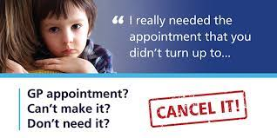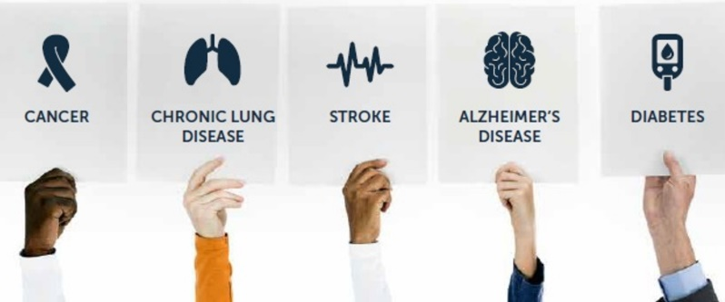

**DID NOT ATTEND!**

159 patients didn’t attend their appointment in August.

If you are unable to attend your appointment please let the surgery know, we can then allow another patient to be seen in your place.

**MMR - Is your child up to date?**

Measles cases are rising in England and across Europe. Measles can make children seriously unwell with one in five needing a hospital visit.

MMR vaccination is free on the NHS with the first dose being offered when a child is one and the second at 3 years and 4 months old. This provides long lasting protection against measles, mumps and rubella.

If your child hasn’t yet had their measles, mumps, and rubella (MMR) vaccine, we encourage you to contact us to book an appointment. The MMR vaccine is safe, free and helps protect your child against these potentially serious illnesses.